Jobs sagemaker
Trial job : 2000 rows output
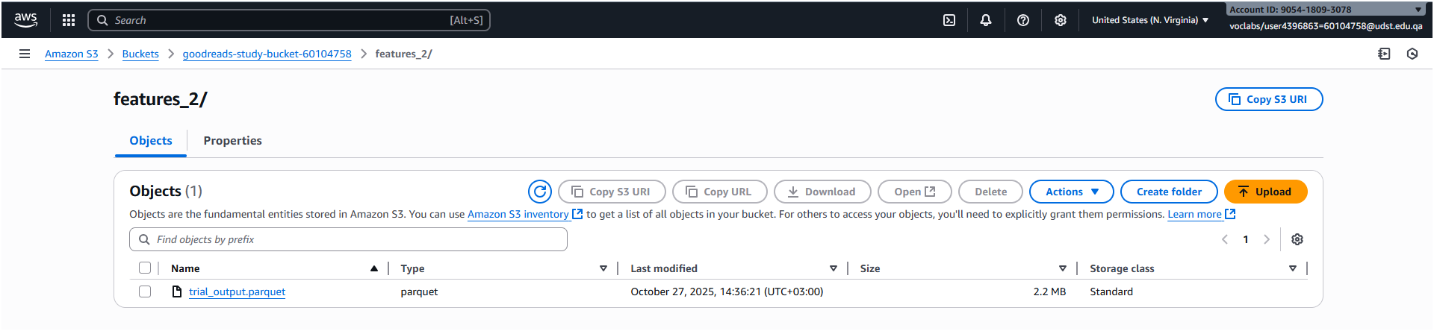
Trial job : 5000 rows output
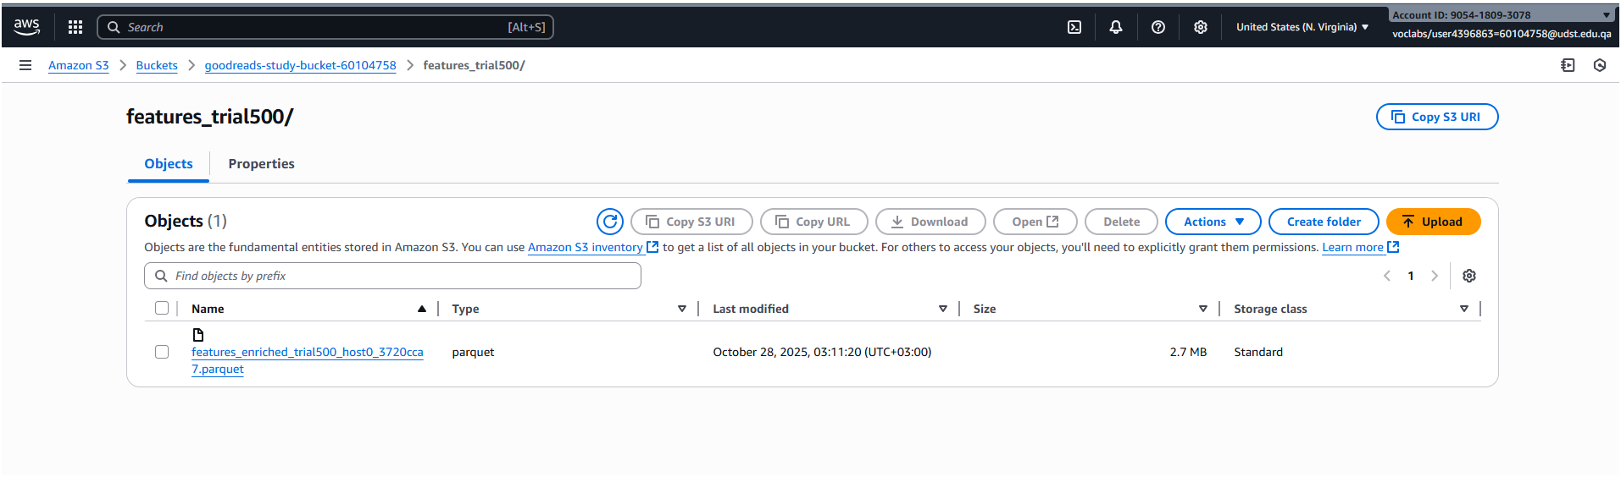

Full features output
